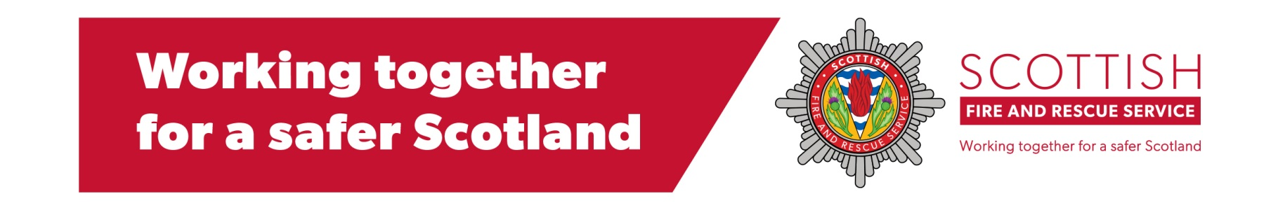

FORTROSE COMMUNITY FIRE STATION
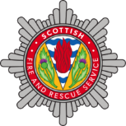
Retained “On-Call” Firefighter Recruitment Information Session

Following the devastating fire on Sunday 4th July in Fortrose we are calling for members of the local community to come forward and find out more about the role of a Retained Duty System Firefighter and how to apply.
The incident has highlighted the incredible commitment that people provide to their community by being Retained Firefighters, but we need to hear from more local people who want to do the same to ensure Fortrose always has the required Fire Cover.
Please come along to our information session and find out more about becoming a Retained Firefighter.
WHERE: FORTROSE COMMUNITY FIRE STATION
WHEN: TUESDAY 13th July @ 1930 – 21:00 hrs

For more information call 07920478954 or 07971 138193
Follow us on Twitter @SFRS_RShire
& Facebook (Ross-Shire Community Fire Stations)

